PROBLEMS WITH

SINGS

GS
SIGNS

Most English problems on these signs are obvious. Some are so bad that they don’t make any sense at all, which also means they cannot be corrected, only laughed at. But a few of them deserve our attention and an explanation as to why they are incorrect. Here are some helpful comments on some of the signs
Some of the signs are simply spelling errors. That may seem trivial, but a sign is something posted in public where a seemingly insignificant spelling mistake can make a person or company look quite unintelligent. Examples of misspelled signs include:
- KENTURKEY: It should be spelled KENTUCKY. There’s another mistake here, in case you didn’t catch it. The Chinese words 肯德基, when directly translated, does refer to the American state of Kentucky. However, the purpose of the sign here is to indicate there is a KFC restaurant there. KFC stands for Kentucky Fried Chicken. We never just call the restaurant “Kentucky.”

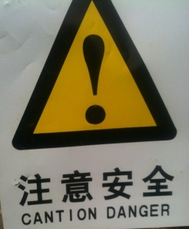
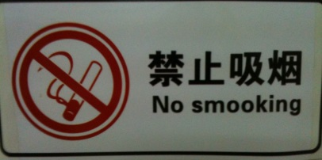
- CANTION DANGER: Another easy mistake to spot. The first word is intended to be CAUTION. Actually, a similar sign in a native English speaking country would probably not use the words CAUTION and DANGER together. In most cases, only one of these words is needed. Normally, after the word CAUTION, you would find the reason you need to be cautious. For example, it may say something like CAUTION WET FLOOR.

- NO SMOOKING: I have no idea what “smooking” means, but whatever it is it is not allowed in that place! Obviously, the sign should read, NO SMOKING. But, “No Smooking?” It’s no wonder people were still smoking in that place!

- You probably had no problem figuring this one out. SUDWICH is not an English word. As you already know, it should be SANDWICH. Also, the English would appear a little more professional if they had put a space between “CAKE” and “&” and a space before SANDWICH.

- GENTIEMEN: It should be GENTLEMEN, but the reason for the mistake is obvious: The lower case (small)letter for “L” is “I” which looks like the upper case “I.” Lower case “i” should be “I.” Most likely the sign makers didn’t really know the English word “Gentlemen” but when looked at the English word they copied from they thought the lower case “L” (l) was an upper case “i.” So, I’m guessing, when they decided to write the sign in all upper case letters, they assumed it was supposed to be “I” (upper case i).
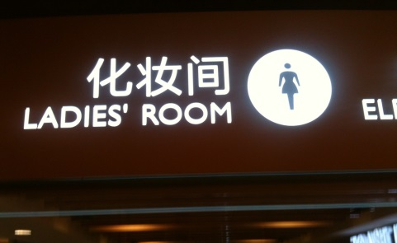
Spelling isn’t the only problem we see on some of these signs. The following problems may be easy to spot for you, but for other people it may be more difficult to see what’s wrong.
- LADIES’ ROOM is correct for a ladies restroom (toilet) door, but this sign is not on the door of a toilet. The white circle with a lady in the middle does look like something you would see on a toilet door. However, this sign was posted outside a ladies Changing (or “dressing”) room.
- EXPORT is a correct translation of 出口 when the meaning is to sell goods to another country. This sign is not on the office door of an export company. It is at the EXIT of a parking lot.
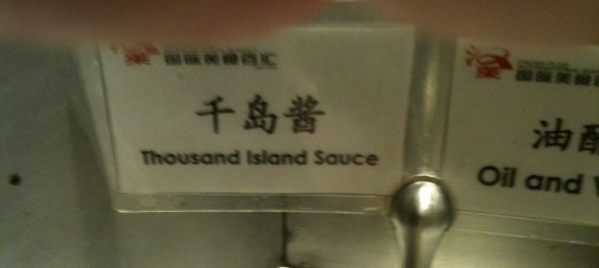
- THOUSAND ISLAND SAUCE I an easy mistake to make because for some things 酱 is “sauce.” But, 沙拉酱is not “salad sauce.” It is “salad dressing.” Thousand Island is a popular kind of salad dressing. The sign should read, “Thousand Island Dressing.”
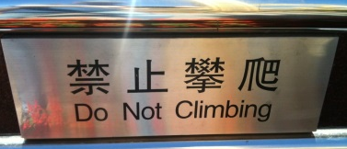
- If you have studied English grammar for a year or more you can easily see the error here. The sign should either say DO NOT CLIMB, or NO CLIMBING.

